**Labour Market Bulletin**

**Manitoba**

**November 2011**

Labour Market Information Directorate

Western Canada and Territories Region

Labour Market and Social Development Programs

Service Canada

[www.workingincanada.gc.ca](http://www.workingincanada.gc.ca/)

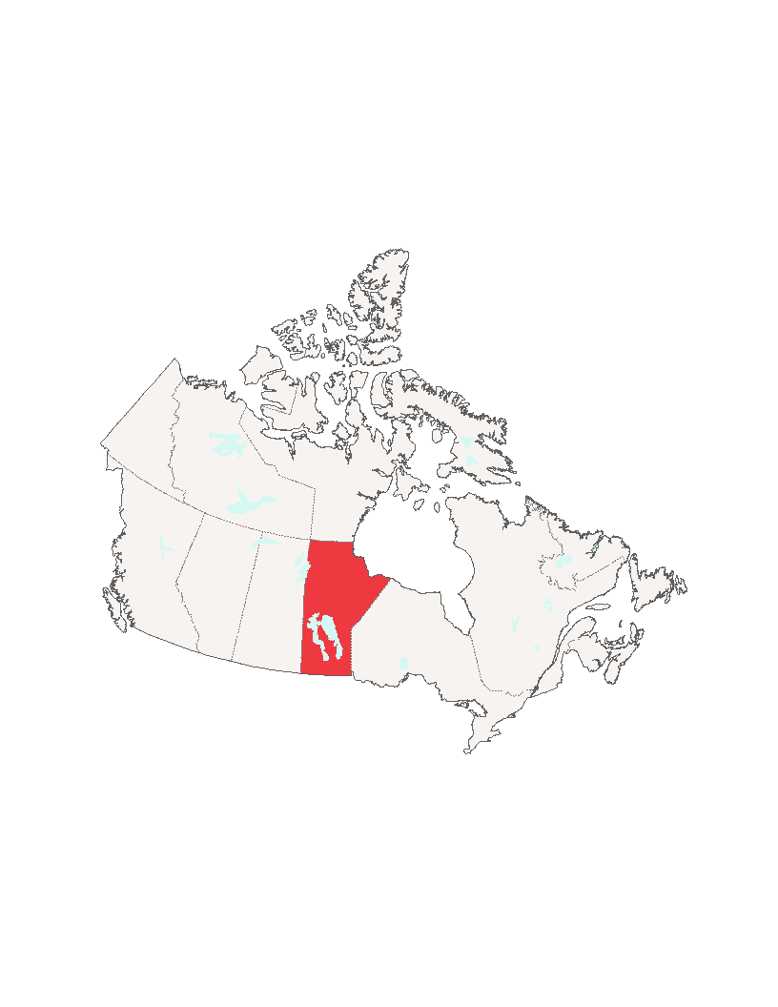

The Labour Market Bulletin is produced monthly by economists and labour market analysts employed by Service Canada in the Western Canada and Territories Region.

Content is intended for personal and public non-commercial use.



**We welcome your feedback**

**E-Mail:**

[W-T-Bulletin-Editor-Editeur-SC-GD@hrdc-drhc.net](mailto:W-T-Bulletin-Editor-Editeur-SC-GD@hrdc-drhc.net)

**Mailing Address:**

Editor, Labour Market Bulletin

Service Canada - Western Canada and Territories Region

Labour Market Information Services

Western Canada and Territories Region

Service Canada

266 Graham Avenue

Winnipeg, Manitoba, R3C 0K3

**Bulletins are available on-line:**

[www.servicecanada.gc.ca/eng/mb/LMBulletins/manitoba_bulletin.shtml](http://www.servicecanada.gc.ca/eng/mb/LMBulletins/manitoba_bulletin.shtml)

**Province-wide**

**Uncertain U.S. markets affect Manitoba outlook:** While market analysts are forecasting weaker growth in Manitoba due to uncertainty south of the border, two factors may change Manitoba’s fortunes. The recent depreciation of the Canadian dollar may help stimulate U.S.-based purchases of Canadian manufacturing goods, while weather-related disturbances in other parts of the world may encourage greater demand for agricultural commodities. Key Source: TD Economics, Provincial Economic Update, September 22, 2011.

**Manitoba job creation not on pace with labour market growth:** The provincial economy added 1,900 jobs last month but saw an increase of 3,300 new workers. As a result, Manitoba’s unemployment rate edged up slightly to 5.5% in September. This is hardly cause for gloom, though, as Manitoba’s unemployment rate remains the second lowest in Canada. Furthermore, the province saw increases last month in the working-age population and in labour force participation, both good signs for Manitoba employers. Key source: Statistics Canada, September 2011.

**Manufacturing sales down:** Manufacturing sales in Manitoba were down 2.4% in August compared to July. August's seasonally adjusted sales of $1.3 billion represented an 8.2% gain over the same period last year and exceeded the national year-over-year increase of 6.7%. Manufacturing is one of Manitoba’s largest economic sectors, and is therefore a good indicator of the province’s overall economic health. The performance of the U.S. economy will have a major impact on Manitoba’s manufacturing sector over the coming year and will dictate investment and production at local firms. Key Source: Statistics Canada, October 14, 2011.

### Retail sales are up: Year-over-year retail sales were up by 4.1% in Manitoba in August 2011. This is slightly higher than the national average of 3.8% and good news for local retailers going into the holiday season. Increased retail spending also creates important employment opportunities, particularly for Manitoba’s low-skilled labour force. Key Source: Statistics Canada, October 25, 2011.

**Provincial government commitment expected to create education jobs:** Starting in 2012, Manitoba will begin reducing class size to a maximum of 20 students from kindergarten to grade 3. This five-year initiative includes the allocation of $20 million to hire additional teachers and $85 million to expand class space. Key Source: Province of Manitoba, October 25, 2011.

Winnipeg

**Demolition plan approved:** Winnipeg's downtown development committee has approved the removal of the former A&B Sound building from the city’s building conservation list. This approval means that the building will be demolished to make room for a new $40 million hotel, retail and office complex across the street from the MTS Centre. Demolition work at the site is set to begin in November, with construction expected to start early next year. Key Source: Winnipeg Free Press, October 3, 2011.

### Two new restaurants opening: Two U.S.-based restaurant chains, Woody’s Bar-B-Q and Famous Dave’s, are opening new locations in Winnipeg. Construction of Woody’s Bar-B-Q is expected to begin in November, with the restaurant ready to open next March. Meanwhile, Famous Dave’s will open next June in the former Blockbuster Video space in the Transcona area. Along with providing jobs during the construction phase, these restaurants will create a number of service sector job opportunities when they open next year. Key Source: Winnipeg Free Press, October 8, 2011.

**Downtown building redevelopment plan:** Winnipeg-based property management firm, Public Capital Co., expects to spend $8 million to refurbish its downtown seven-storey Canada Building. The company has signed a 20 year office leasing agreement with Manitoba Housing and Community Development to provide 71,100 square feet of office space. The company has hired construction staff to begin work on the top four floors of the building, while the second phase of the project will get underway early next year. Construction is expected to be complete in early 2013. Key Source: Winnipeg Free Press, October 11, 2011.

### Redevelopment plan approved: Winnipeg City Council’s executive policy committee has approved $10 million worth of loans to developer Gem Equities. The developer plans to build 900 new housing units on the former CN Fort Rouge Yards. Construction of the $79.4 million project is expected to begin this year and should be complete by 2015. This development, which represents the largest infill housing project in the city’s recent history, will increase demand for construction trades’ workers in a market that is already overheated with several large-scale developments underway. Key Source: Winnipeg Free Press, October 12, 2011.

### Layoffs at manufacturing firm: Alphair Ventilating Systems Inc. has laid off three senior managers and 20 employees. The weak North American economy is being blamed for the restructuring. The company, which manufacturer’s industrial fans for the mining and processing industries, has about 80 employees on staff following the layoffs. Key Sources: Winnipeg Free Press, October 13, 2011; Service Canada contact, October 13, 2011.

**Bank opening new branch:** Canadian Western Bank plans to open a new location in Winnipeg’s Tuxedo Business Park next year. Construction of the new building will start in November and is expected to be complete by summer 2012. Benefits of this project include jobs during the construction phase, as well as employment opportunities in commercial banking and financial services when the bank opens next year. Key Sources: Winnipeg Free Press, October 13, 2011; Service Canada contact, October 13, 2011.

### Construction starts at old arena site: Construction is underway on a new $36 million, three-storey office and retail complex at the former Winnipeg Arena site. Western Financial Group will be the anchor tenant at the new complex as the company plans relocate all four of their Winnipeg-based operations to the site in 2013. Benefits of this project include demand for skilled trades’ people during construction, as well as employment opportunities in the insurance, banking and retail service industries once construction is complete. Key Source: Winnipeg Free Press, October 19, 2011.

### Maple Leaf restructuring plan: Maple Leaf Foods announced a three year, $560 million company-wide restructuring plan to modernize and consolidate its production facilities. As a result, a small Winnipeg-based processing plant will close by the end of 2014, affecting 27 jobs. However, 350 jobs will be created at Maple Leaf’s St. Boniface ham-processing plant, which will undergo an $85 million expansion. The expansion project, which will get underway immediately and should be finished by 2013, will create about 110 jobs during the construction phase. Key Source: Winnipeg Free Press, October 20, 2011.

**New Cineplex cinema:** Cineplex is spending $4.5 million to convert the second-run Cinema City on McGillivray and Kenaston Boulevard into a first-run multiplex. Renovation work is slated to begin early next year and should be complete by summer 2012. This project will provide employment opportunities for skilled construction workers and once complete, will create a number of service sector jobs. Key Source: Winnipeg Free Press, October 20, 2011.

Northern Manitoba

**Interlake area – Flood work:** The Peguis Flood Team has completed work at Steep Rock, where they constructed massive sandbag dikes to help fight flooding on Lake Manitoba. Over 70 term employees worked on the project, including sandbaggers and heavy equipment operators. Those employed were members of Peguis, Fisher River and Kinonjeoshtegon First Nations. Key Sources: Winnipeg Free Press, October 5, 2010; Service Canada contact with the Peguis Emergency Centre, October 5, 2010.

**Thompson – Airport upgrade:** Runway 06-24 has re-opened at Thompson Airport, following the completion of an $8.6 million rehabilitation project. Maple Leaf Construction reports that the project generated about 16,000 man-hours of employment for heavy equipment operators, truck drivers, paving mechanics, labourers and electricians. Key Sources: Thompson Citizen, October 14, 2011; Service Canada contact with Maple Leaf Construction, October 18, 2011.

### The Pas – Investment in forestry: Tolko Industries Ltd. has received a $2.5 million investment from the Government of Canada. Not only will this funding help Tolko expand market opportunities for its wood and pulp and paper products, but it will also help to protect local jobs. Tolko’s Kraft Paper and Solid Wood division’s employ over 300 people in administration, electrical engineering, management, maintenance and production positions. Key Sources: Government of Canada news release, October 13, 2011; Service Canada contact with employer, October 19, 2011.

Southern Manitoba

**Winkler – New construction:** Construction activity continues to be strong in Winkler. Building permits in the city totalled a record $53 million for the first eight months of 2011. Eight institutional permits accounted for over half of the city’s total. This represents good news, as increased construction activity creates demand for local contractors and skilled trades’ workers. Key Source: The Winkler Times, September 22, 2011.

**Killarney- New water supply system:** The Town of Killarney is changing its drinking water supply source from Lake Killarney to a well located northeast of the community. The first phase of the project was completed this summer, which included the construction of a pipeline from the well to the town’s water treatment plant. Phase two of the $7.5 million project is expected to start next May, with completion by October 2012. This project will not only provide the community with better quality water, but it will also provide a variety of employment opportunities for trades’ workers and engineers during the construction phase. Key Source: The Guide, Killarney, September 30, 2011.

### Winkler – New school construction: Construction has begun on the new $32.1 million Northlands Parkway Collegiate in Winkler. Along with providing trades’ jobs during construction, the new school will provide employment opportunities for education and childcare workers when it opens in September 2013. Key Source: The Winkler Times, October 13, 2011.

**Carman - Dental office expansion:** Dufferin Dental Centre is undergoing an expansion. Renovation work at the dental office begins next week and should be complete by late November. As a result of the expansion, the centre plans to hire a receptionist, a hygienist, a dental assistant and a treatment co-ordinator. Key Sources: The Valley Leader, October 14, 2011; Service Canada contact, October 13, 2011.

**Brandon – Market construction:** Construction of a global market on the site of the former Perth’s building in Brandon will begin next spring. The market site will be set up for 20 vendors and will also include a food court. Future plans at the site include the development of a park and an indoor farmer’s market. This project will create employment opportunities for construction and landscaping workers during the construction phase, as well as development opportunities for market gardeners and small businesses in the future. Key Source: Brandon Sun, October 26, 2011.

**Swan River - Parkland Regional Health Authority doctor recruitment:** Swan River’s only obstetrician/gynaecologist relocated to Winnipeg, effective October 18, forcing the Parkland Regional Health Authority to suspend obstetrician services. The health authority requires physicians that can perform emergency surgeries for complicated deliveries. In order to meet this need in the future, they plan to hire family physicians with advanced training instead of specialists. Key Source: The Dauphin Herald October 18, 2011.

**Virden - New hotel creates jobs:** The Comfort Inn and Suites opened a new 60 room hotel in Virden on October 19. Construction of the $6 million building began last November, creating months of employment for local trades' people. The Comfort Inn has hired 22 people to operate the hotel. Key Source: Virden Empire-Advance, Dillon Clark Manager/Owner Comfort Inn and Suites October 21 and October 25, 2011.

Selkirk Area

### Stonewall – Museum set to open: The Quarry Park Heritage Arts Centre's museum will officially re-open in November after a fire destroyed the former Interpretive Centre four years ago. As a result, two new full time positions have been created, including a Visitor Services Coordinator position and a Custodian position. In addition, three part-time employees have been hired to work in visitor services. Key Sources: Stonewall Argus, October 13; Service Canada contact with employer, October 13, 2011.

**Lake St. Martin – Construction of flood channel:** Construction of the Lake St. Martin emergency channel is over 75% complete and should be finished in November. Plans are now underway for construction of an extended reach of the channel from Buffalo Creek to Lake Winnipeg. Over 130 employees and 95 pieces of heavy equipment are on site at the project. Key Source: Province of Manitoba news release, October 19, 2011.